PoD
- Pyrate Captain
- Member

- 696 posts
- Gender:Male
- Location:Warrington UK
- Interests:Pirates, graphic novels, computer art, Listening to music, Going to gigs, Beer and Wine drinking, historical research, Period weaponry and Leatherwork
Posted May 18, 2011 · Report post
I just came across this 1716 Affidavit about burial instructions. Its got a rather nice skull and crossbones design on it which would look cool on a flag and its a period design too.
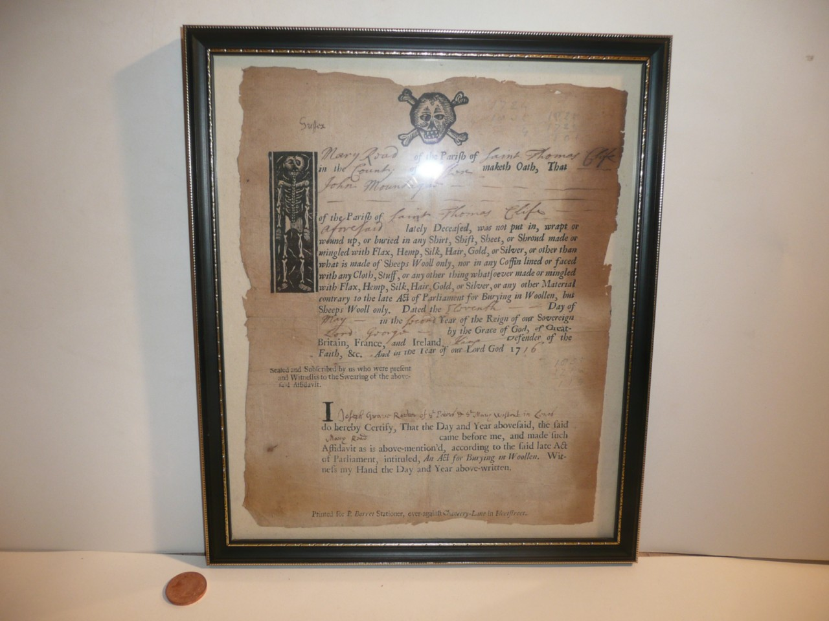
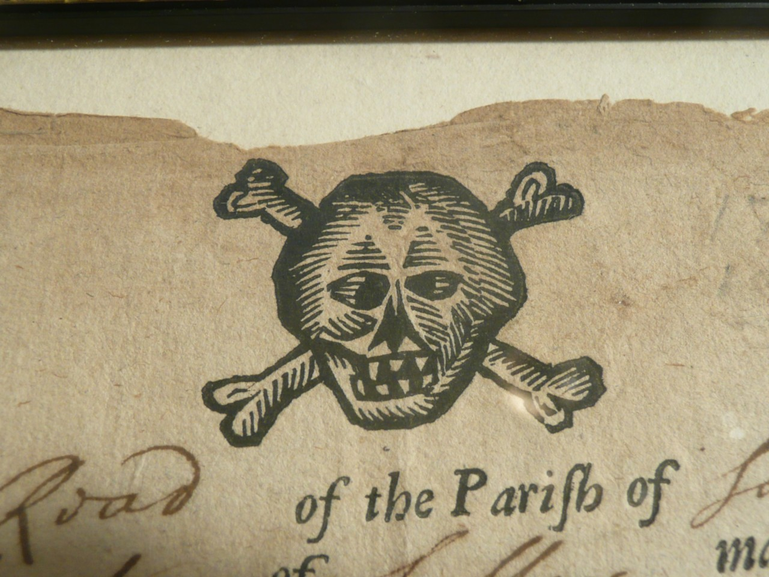

jendobyns
- Pyrate Captain
- Member

- 562 posts
- Gender:Female
- Location:Baltimore
- Interests:too numerous to mention, really. Period foodways, baroque dance, material culture, etc., etc.
Posted May 18, 2011 (edited) · Report post
Cool! It even appears to have fangs! Or sharply filed teeth.
Edited May 18, 2011 by jendobyns

Capt. Sterling
- Sticky Fingers Sterling Needs a New Hat
- Member

- 10,302 posts
- Gender:Pyrate Hunter
- Location:here
- Interests:Killing pirates, haven't met one yet worth keeping alive....
Posted May 18, 2011 · Report post
Ahem... a bit more interested in what it has to say... mind a better photo of the text or can you type it out?

LadyBarbossa
- Wealth Redistributor & Mischief Making
- Moderator

- 4,641 posts
- Gender:Female
- Location:The Land Between Two Rivers, aka Iowa
- Interests:18th c Piracy to American Revolution, Victorian Thespians, Equitation, tigers, Friesians, cooking, playing my viola & music in general. Researcher of Major General Baron Johann de Kalb. LOVES the Phantom of the Opera (who's also Brethren)! Transformers, Stargate, Star Trek, Star Wars, NCIS, Bones, The X Files
Posted May 19, 2011 · Report post
The design is fantastic. But loving the document as well. Incredible info. So, NOTHING but sheeps wool was what they were buried in? I'm curious about this "Act of Parliment" that dictates how one was buried.
~Lady B

PoD
- Pyrate Captain
- Member

- 696 posts
- Gender:Male
- Location:Warrington UK
- Interests:Pirates, graphic novels, computer art, Listening to music, Going to gigs, Beer and Wine drinking, historical research, Period weaponry and Leatherwork
Posted May 19, 2011 · Report post
On 5/18/2011 at 11:53 PM, Capt. Sterling said:
Ahem... a bit more interested in what it has to say... mind a better photo of the text or can you type it out?
heres the ebay auction where its for sale: http://cgi.ebay.co.u...=item588e16777d
On 5/19/2011 at 1:52 AM, LadyBarbossa said:
I'm curious about this "Act of Parliment" that dictates how one was buried.
http://www.traceyour.../woollenact.htm
and also a more period reference from 1729:
http://books.google.co.uk/books?id=DpAGAAAAMAAJ&dq=Burial%20in%20Woollen%20Act&pg=PA750#v=onepage&q=Burial%20in%20Woollen%20Act&f=false
and 1713
http://books.google.co.uk/books?id=LqIOAAAAQAAJ&dq=Burial%20in%20Woollen&pg=PA138#v=onepage&q&f=false

Jas. Hook
- Scourge o' the 7 Seas
- Member

- 1,650 posts
- Gender:Male
- Location:Long Island NY
- Interests:Fishing & Piracy
Posted May 19, 2011 · Report post
On 5/19/2011 at 1:52 AM, LadyBarbossa said:
The design is fantastic. But loving the document as well. Incredible info. So, NOTHING but sheeps wool was what they were buried in? I'm curious about this "Act of Parliment" that dictates how one was buried.
~Lady B
Lady B -
Here is the Wiki quikie on it...
My you itch forever in the hereafter. :angry:
From Wikipedia, the free encyclopediaJump to: navigation, search The Burial in Woollen Acts 1666-80 were Acts of the Parliament of England (citation 18 & 19 Cha. II c. 4 (1666) ^{[1]}, 30 Cha. II c. 3 (1678) ^{[2]} and 32 Cha. II c. 1 (1680) ^{[3]}) which required the dead, except plague victims, to be buried in pure English woollen shrouds to the exclusion of any foreign textiles^{[4]}. It was a requirement that an affidavit be sworn in front of a Justice of the Peace (usually by a relative of the deceased or some other credible person) confirming burial in wool, with the punishment of a £5 fee for noncompliance. Parish registers were marked with the word affidavit or with a note A or Aff against the burial entries to confirm that affidavit had been sworn, or marked "naked" for those too poor to afford the woollen shroud. Some affidavits survive. This legislation was in force until 1814, but was generally ignored after 1770. These related records are generally regarded as a source of genealogical information, and can help provide evidence of economic status and relationships that may be unavailable elsewhere or ambiguous.
Jas. Hook

Mission
- Goat Specialist
- Admin

- 5,082 posts
- Gender:Male
- Location:Monroe, MI
- Interests:Scholarly piracy, designing and creating haunted house rooms and props, movies, abstract thinking, abstruse thinking, obstructive thinking, ideating, random thinking, movies, cartoons, movies, movies scores, cycling, world peace and small furry dogs, movies, writing, drawing, personal skills training, gremlins and, of course, lest I forget, movies.
Posted May 19, 2011 · Report post
Apparently this skull was drawn after celebrating the taking of a merchant ship loaded with alcohol. It's cross-eyed!

Capt. Sterling
- Sticky Fingers Sterling Needs a New Hat
- Member

- 10,302 posts
- Gender:Pyrate Hunter
- Location:here
- Interests:Killing pirates, haven't met one yet worth keeping alive....
Posted May 19, 2011 (edited) · Report post
On 5/19/2011 at 8:50 AM, PoD said:
On 5/18/2011 at 11:53 PM, Capt. Sterling said:
Ahem... a bit more interested in what it has to say... mind a better photo of the text or can you type it out?
heres the ebay auction where its for sale: http://cgi.ebay.co.u...=item588e16777d
Thank ye PoD, will make a lovely addition to all the mourning clothes and grave clothes...
Edited May 19, 2011 by Capt. Sterling

PoD
- Pyrate Captain
- Member

- 696 posts
- Gender:Male
- Location:Warrington UK
- Interests:Pirates, graphic novels, computer art, Listening to music, Going to gigs, Beer and Wine drinking, historical research, Period weaponry and Leatherwork
Posted May 19, 2011 · Report post
cool. I thought it was just me who was obsessed with 17th/18th century documents ha ha

William Brand
- Mercury Malefactor
- Admin

- 8,884 posts
- Gender:Male
- Location:Logan, Utah
- Interests:My name is William Pace and I live and work as a graphic designer, illustrator and photographer in Northern Utah. I'm married to the lovely Tracy Pace and we have three children. In addition to all things art, I enjoy traveling and meeting new people from every walk of life. I've always been a fan of history, theology, and of course, Pyracy.
http://www.youtube.com/watch?v=PSkt-q-HihQ
Posted May 19, 2011 · Report post
Fantastic. I already snagged it and took out most of the glass glare and oriented it.
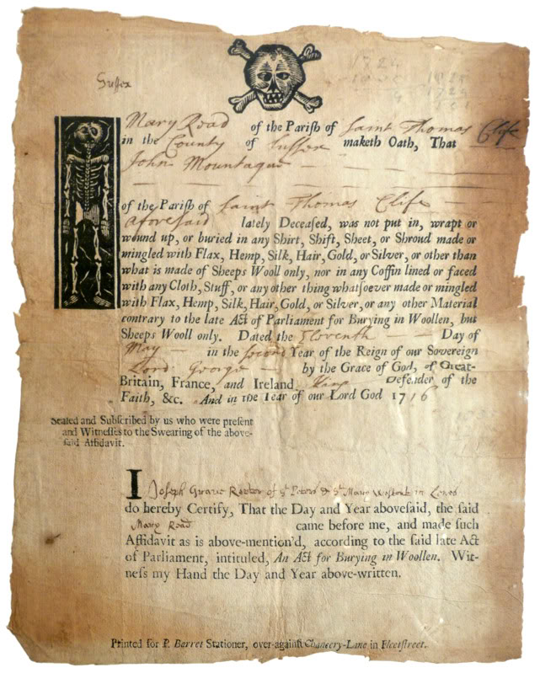
Some details...
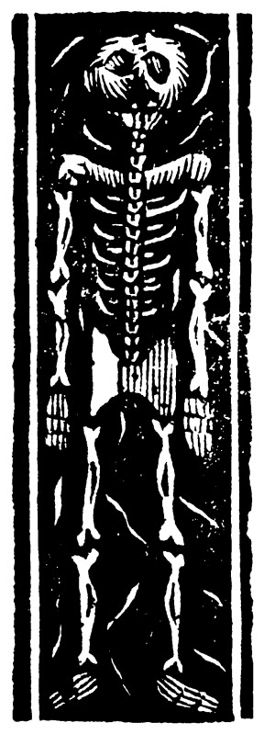

Capt. Sterling
- Sticky Fingers Sterling Needs a New Hat
- Member

- 10,302 posts
- Gender:Pyrate Hunter
- Location:here
- Interests:Killing pirates, haven't met one yet worth keeping alive....
Posted May 19, 2011 · Report post
On 5/19/2011 at 1:52 PM, PoD said:
cool. I thought it was just me who was obsessed with 17th/18th century documents ha ha
I obsess over everything...
and thank you William

Mission
- Goat Specialist
- Admin

- 5,082 posts
- Gender:Male
- Location:Monroe, MI
- Interests:Scholarly piracy, designing and creating haunted house rooms and props, movies, abstract thinking, abstruse thinking, obstructive thinking, ideating, random thinking, movies, cartoons, movies, movies scores, cycling, world peace and small furry dogs, movies, writing, drawing, personal skills training, gremlins and, of course, lest I forget, movies.
Posted May 20, 2011 · Report post
Outstanding work William! A whole skeleton! Who doesn't like to see that?

William Brand
- Mercury Malefactor
- Admin

- 8,884 posts
- Gender:Male
- Location:Logan, Utah
- Interests:My name is William Pace and I live and work as a graphic designer, illustrator and photographer in Northern Utah. I'm married to the lovely Tracy Pace and we have three children. In addition to all things art, I enjoy traveling and meeting new people from every walk of life. I've always been a fan of history, theology, and of course, Pyracy.
http://www.youtube.com/watch?v=PSkt-q-HihQ
Posted May 20, 2011 · Report post
Don't thank me. Thank our intrepid friend for finding them.
It's a good document of the times. The wording is fairly simple and straight forward for a legal document. I typed up a blank version.
(Name of Primary Witness) of the Parish of (Name of Parish)
in the (Designation of Area - Example: County, Shire, etc) of (Name of Area) maketh Oath, That
(Name of Person or Persons being buried)
of the Parish of (Name of Parish and 'abovesaid' if the same)
lately Deceased, was not put in, wrapt or
wound up, or buried in any Shirt, Shift, Sheet, or Shroud made or
mingled with Flax, Hemp, Silk, Hair, Gold, or Silver, or other than
what is made of Sheeps Wooll only, nor in any Coffin lined or faced
with any Cloth, Stuff, or any other things whatsoever made or mingled
with Flax, Hemp, Silk, Hair, Gold, or Silver, or any other Material
contrary to the late Act of Parliament for Burying in Woollen, but
Sheeps Wooll only. Dated the (Numerical day of the Month) Day of
(Name of Month) in the (Year of Reign) Year of the Reign of our Sovereign
(Name of Sovereign) by the Grace of God, of Great
Britain, France, and Ireland, (King or Queen) Defender of the
Faith, &c. And in the Year of our Lord God 17 (Year)
Seated and Subscribed by us who were present
and Witnesses to the Swearing of the above-
said Affidavit. (Place for additional Witnesses)
I (Name of Certifying Witness, Title, Occupation, Place of Origin, etc. as the Witness may see fit)
do hereby Certify, That the Day and Year abovesaid, the said
(Name of Primary Witness) came before me, and made such
Affidavit as is above-mention'd, according to the said late Act
of Parliament, intituled, And Act for Burying in Woollen. Wit-
ness my Hand the Day and Year above-written.
Printed for P. Barret Stationer, over-against Chancery-Lane in Fleetstreet.

PoD
- Pyrate Captain
- Member

- 696 posts
- Gender:Male
- Location:Warrington UK
- Interests:Pirates, graphic novels, computer art, Listening to music, Going to gigs, Beer and Wine drinking, historical research, Period weaponry and Leatherwork
Posted May 20, 2011 · Report post
cool thats saved me some time as I had that on my to-do list for the weekend. I'm not sure where the document would fit in from a maritime point of view but its a nice one to have lying around.
Makes you wonder if it was still the law that you had to be buried in wool if you were buried at sea

Capt. Sterling
- Sticky Fingers Sterling Needs a New Hat
- Member

- 10,302 posts
- Gender:Pyrate Hunter
- Location:here
- Interests:Killing pirates, haven't met one yet worth keeping alive....
Posted May 20, 2011 · Report post
Hmmm good question. Have not come across anything other than being sewn up in canvas of some sort.. now it may have made a difference for higher ranking crew members as it was stated in Devil and the Deep Blue sea that if it was feasible, they would sail to the closest bit of land to bury them as burying in the ground was thought to be a better guarantee of being "disposed" of properly... What I find interesting is that there is a penalty for not being buried in wool in England but everyone seems to be buried in linen over in the English American colonies during the same time frame...

Mission
- Goat Specialist
- Admin

- 5,082 posts
- Gender:Male
- Location:Monroe, MI
- Interests:Scholarly piracy, designing and creating haunted house rooms and props, movies, abstract thinking, abstruse thinking, obstructive thinking, ideating, random thinking, movies, cartoons, movies, movies scores, cycling, world peace and small furry dogs, movies, writing, drawing, personal skills training, gremlins and, of course, lest I forget, movies.
Posted May 20, 2011 · Report post
Unless people were drastically different than today, my thought is that many of them probably just threw them overboard in what they were wearing unless someone was looking. (Especially if someone was mangled in battle. Imagine re-dressing that.) Why does fish food really need to be wrapped in wool? (Then again...why does worm food? The wool manufacturer's guild demanded it?)

Capt. Sterling
- Sticky Fingers Sterling Needs a New Hat
- Member

- 10,302 posts
- Gender:Pyrate Hunter
- Location:here
- Interests:Killing pirates, haven't met one yet worth keeping alive....
Posted May 20, 2011 (edited) · Report post
Well a belief in the Here After and what you had to do in order to get there seems to have played a very important role back then, although I suppose it really made a difference who you were burying as well... Consider: they supposedly sewed Charles II's head back on due to the belief one could not enter Heaven in pieces...if they would go to the trouble to bring Captains back to be buried on land, so as not to have the body disturbed.. being mangled seems have been a problem for them.
Remember families used to fight to save the bodies of family members who were hanged for crimes, with bidding wars going on for the bodies, to keep them away from the dissection tables
Edited May 20, 2011 by Capt. Sterling

PoD
- Pyrate Captain
- Member

- 696 posts
- Gender:Male
- Location:Warrington UK
- Interests:Pirates, graphic novels, computer art, Listening to music, Going to gigs, Beer and Wine drinking, historical research, Period weaponry and Leatherwork
Posted May 20, 2011 · Report post
On 5/20/2011 at 1:43 PM, Mission said:
Unless people were drastically different than today, my thought is that many of them probably just threw them overboard in what they were wearing unless someone was looking. (Especially if someone was mangled in battle. Imagine re-dressing that.) Why does fish food really need to be wrapped in wool? (Then again...why does worm food? The wool manufacturer's guild demanded it?)
you might not be far wrong on that. In one of the books i link to about it seems that they were trying to get better sales of wool so the two might be related. Also I think there is mention of people being buried in wool in the bible so maybe it was something to do with that too.
Anyway heres a little present for you all. I recreated the document using Williams translation and pictures. The pdf is actual size of 7.5" x 9" ready for you all to print on a sheet of laid paper
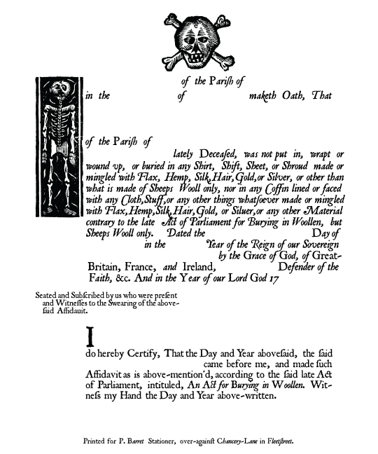
http://www.cybercyde...s/affidavit.pdf

Mission
- Goat Specialist
- Admin

- 5,082 posts
- Gender:Male
- Location:Monroe, MI
- Interests:Scholarly piracy, designing and creating haunted house rooms and props, movies, abstract thinking, abstruse thinking, obstructive thinking, ideating, random thinking, movies, cartoons, movies, movies scores, cycling, world peace and small furry dogs, movies, writing, drawing, personal skills training, gremlins and, of course, lest I forget, movies.
Posted May 20, 2011 · Report post
I've been collecting accounts of bodies being buried on land vs. at sea from the different journals I've read (for my book as this falls under the role of the surgeon...sort of...) and it's about half and half as I've mentioned before. I also have some accounts of amputated limbs being thrown overboard as well.

William Brand
- Mercury Malefactor
- Admin

- 8,884 posts
- Gender:Male
- Location:Logan, Utah
- Interests:My name is William Pace and I live and work as a graphic designer, illustrator and photographer in Northern Utah. I'm married to the lovely Tracy Pace and we have three children. In addition to all things art, I enjoy traveling and meeting new people from every walk of life. I've always been a fan of history, theology, and of course, Pyracy.
http://www.youtube.com/watch?v=PSkt-q-HihQ
Posted May 20, 2011 · Report post
Oh that is very fine! Very fine indeed. Anytime you want a file cleaned up, just let me know. It's worth the finished product. You saved me a little foray into ligature.

Capt. Sterling
- Sticky Fingers Sterling Needs a New Hat
- Member

- 10,302 posts
- Gender:Pyrate Hunter
- Location:here
- Interests:Killing pirates, haven't met one yet worth keeping alive....
Posted May 21, 2011 · Report post
Well thank ye both...saves my Quartermaster a ton of work...

Jack Roberts
- Dread Pyrate
- Member

- 1,063 posts
- Gender:Male
- Location:Orlando, FL
Posted May 21, 2011 · Report post
Hey!!
Do we have the actual documents dimensions? I do love the Skull and Crossbones.

Jack Roberts
- Dread Pyrate
- Member

- 1,063 posts
- Gender:Male
- Location:Orlando, FL
Posted May 21, 2011 · Report post
Oh nevermind, I looked up the ebay link and found it.
This is way cool. I love finding stuff like this.

